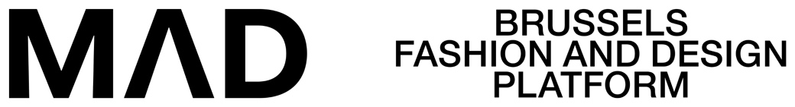

MAD BUSINESS PASS
PROGRAMS

Participation Rules

- PROGRAMME DEFINITION

MAD FLY is a mentoring program that is aimed at small entrepreneurs who want to grow their business, with a value of max €3.600,00VAT included, with professional coaches supporting 6 Brussels based companies in Fashion or Design.

This programme was created with the support of the Ministry of Economy of the Brussels Capital
Region.

- DURATION OF THE PROGRAMME

1 avril 2023 – 1 avril 2024

- QUALIFICATION RULES

- Be based in the Brussels Capital Region and have a VAT number
- Be in business for at least 1 year
- In fashion: have produced at least 1 collection
- In object/textile/industrial/urban/graphic design: Have produced at least 1 object or 1 commissioned project
- Have a development strategy
- Have a communication strategy
- Have at least 1 point of sale in Belgium or internationally

Call for applications will be open from 25th of January 2023 till 10th March 2023, 22:00

The selection process will be carried out in two parts:

PHASE 1 : Selection of applications

Applications for 2022 will be accepted until 10th March 2023, 22:00, after which applications can no longer be accepted.

Following documents are required to be enclosed with the Application Form :
- CV
- Business plan
- latest financial balance sheet
- most recent lookbook or catalogue

PHASE 2 : Jury

The Jury will be held at MAD on Thursday 16th March 2022 – 9:30-15:00

Announcement of the winners: not later than 22nd of March 2023
Kick off meeting with experts: Thursday 30th March 2022 – 9h30-15h

Contact : (before 10th March 2023)

Peggy Acke
business@mad.brussels
T : +32 880 85 66

MAD - Brussels Fashion and Design platform - is a platform of support, expertise and a
for the promotion of the Fashion and Design sectors in Brussels.
Its mission, at the heart of innovation and looking to the future, to promote the professions in these sectors, to encourage initiatives and to support the players in these two sectors, in order to encourage their economic development and the influence of Brussels.
Coordinating the aid and initiatives aimed for them, MAD Brussels ensures the local and international
and international promotion of Brussels' creators and designers, as well as investment in the Brussels
Region for foreign actors. Through the activation of employment sectors and know-how.
Through quality events on a national and international level. Through the development of a network
of exchanges on an international scale. All of this, reinforcing the attractiveness of Brussels, combined with revitalising the Brussels districts in the canal zone.
By doing so, MAD Brussels wants to position the city-region among the traditional European capitals of fashion and design, and to promote the European capitals of fashion and design, as a dynamic, forward-looking, collaborative and universal innovative centre. Created in 2011, the Brussels Fashion and Design Centre Asbl is the result of close collaboration between the European Regional Development Fund (FEDER), the Brussels-Capital Region and the City of Brussels.

